Midterm questions
- What are main tasks of the artificial intelligence?
- What is a rational agent? Give an example of the specific work of the rational agent.
- What is the Depth-first search algorithm? Describe its advantages and disadvantages.
- Describe rational and irrational agents. Give examples of these agents.
- Describe how an agent interacts with the environments. You also need to focus on sensors and actuators.
- Write down a program in Prolog that finds the result of the following equation Z=(X+2*Y)/ln(X) for input numbers X and Y. Do not forget to check for allowable values.
- Write down a program in Prolog that finds the result of the following equation Z=(X-Y) (Y+X) / (2*X - Y) for input numbers X and Y. Do not forget to check for allowable values.
- What are main parts of the artificial intelligence? (5 points)
- Machine learning
- Computer vision
- Applications development
- Natural language processing
- What a search strategy are we going to use if the search space is represented by search trees, and a wanted object is located in upper levels? (5 points)
- Heuristic search
- Backtracking search
- Breadth-first search
- Depth-first search

- What a search strategy are we going to use if the search space is represented by a graph of roads with the distance between nodes? (5 points)
- Uniform cost search
- Breadth-first search
- Backtracking search
- Depth-first search

- What will be a value of the root node if we have the following minimax problem (10 points)?
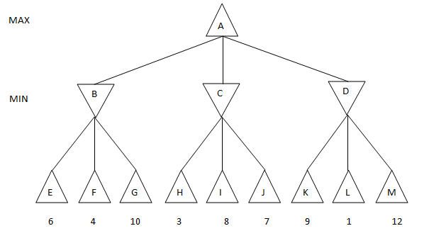
- 7
- 1
- 4
- 6
- What is not a feature of a rational agent? (5 points)
- Sensors
- Actuators
- Restoration
- Performance measure

- What is a specific feature of a rational agent? (5 points)
- A sequence of actions that can be executed
- A sequence of actions that leads to the final goal
- A sequence of actions that minimizes the time required to complete the task
- A sequence of actions that maximizes the performance measure

- What a search strategy are we going to use if the search space is represented by search trees, and a wanted object is located in lower levels? (5 points)
- Backgammon
- Heuristic search
- Depth-first search
- Uniform cost search

- Use the breadth-first and the depth-first search to find a node (10) in this tree (10 points)
